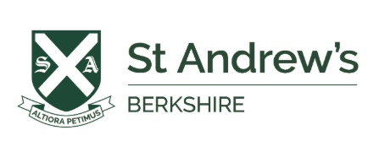
Thursday 2nd July 2026
Dear Year 5 Parents,
Preparation for Senior School Assessments
I hope you are all looking forward to the summer holidays.
Following my letter after half term, I am writing with a few reminders and some guidance on how you can support your child over the summer so that they are ready to start strongly in September.
References
Thank you to those who have completed the references MS Form. Please could I ask those who have not yet done this to fill out as soon as you can, at the beginning of the holidays so that I can start writing references over the summer. Remember to complete this with your child. References MS Form link
Registration
Please keep me informed once you have registered for schools so that we can help coordinate and support where possible.
ISEB Pre-Tests
Several of you have already registered for these.
If your child is applying to schools that use the ISEB Pre-Tests*, you will need to register via the ISEB Portal. This must be completed by parents and then confirmed by the relevant schools. Unfortunately, we cannot set this up from our side, although we can see the registered applicants and the children will sit the tests at St Andrew’s.
If your child requires access arrangements, you will need apply during registration and upload supporting documentation. Mrs Brown will be contacting you with further guidance on exactly what to apply for for your child before the end of this term.
To register:
- Register your child on the Guardian Portal.
- Select St Andrew’s School as the invigilation centre (RG8 8QA).
- Send your child’s Applicant ID to all relevant schools.
- We will then approve your registration.
A support video is available here should you need guidance.
*The main schools that people may be considering that use the Pre-Test are:
Bradfield, Dauntsey’s, Downe House, Eton, Lord Wandsworth, Marlborough, Radley, St Edward’s Oxford, St Swithun’s, Sherborne Boys, Oratory, Wellington, Winchester
Please do get in touch if you are unsure whether a school uses the Pre-Test or internal assessments.

We will be carrying out the Pre-Tests here, at St Andrew’s, on Wednesday 18th and Thursday 19th November. All approved access arrangements will be in place.
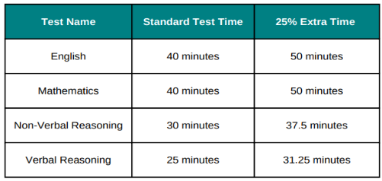
The format of the Pre-Tests will be:

For any who are extra keen, there is an online walkthrough of the test format; however, this can be left until nearer the time and will also be covered in school. ISEB Pre-Tests | Test Walkthrough,

Assessment Days and Interviews
Senior schools will contact you directly with dates for assessment days and/or interviews. Please note that Bradfield may invite candidates from the beginning of September, with assessments taking place in mid-September. Most other schools hold these later in the Autumn or Spring terms.
We will support the children in preparing for these:
- SAS (St Andrew’s Skills, formerly SSP)
Next year I will be teaching your children. Lessons will include philosophy, current affairs, language work, teamwork and continued practice in verbal and non-verbal reasoning. These reflect the skills assessed at senior school selection days.
- Interview Practice
Mr Graham, Mr Gair and I will provide both individual and group interview practice, along with feedback, as assessment dates approach.
A set of sample interview questions is attached. These are not exhaustive, but reflect commonly asked questions. You may wish to practise some of these at home, but please avoid over-rehearsing.


Century assignments will be available throughout the summer for English, maths, verbal and non-verbal reasoning. Starting in the first week of the holiday, there will be weekly assignments set throughout the summer in English, maths, verbal and non-verbal reasoning, with weekly tasks set from the first week of the holidays.
- English: 3–4 nuggets per week, with occasional diagnostics
- Maths: 3 nuggets per week. The fourth nugget (in red on document attached) provides more challenging content; some may wish stretch themselves with this in place of some of the other nuggets.
- Verbal/Non-Verbal: There will only be a focus on verbal reasoning over the summer as Mr Graham has spent a lot of lesson time on non-verbal over this term and last.
Pupils may also follow their personalised Learning Path, which will adapt according to their performance in diagnostic tests and nuggets, or select areas from the Content section.
Children should complete what they can, but should not feel pressure to finish everything. It is more beneficial to focus on areas they most need to improve.
Assignments remain available for one week after their deadline but will be clearly labelled with the week, subject and start date. Please ensure your child has paper and pen available for working.
A full list of assignments is attached.
For additional practice, Century Bond offers optional monthly test packages (approximately £40 per month), including ten practice tests. Century Bond online. A free 7-day trial is available. If useful, you may wish to subscribe for September and October only, as this closely reflects the ISEB format. That said, children will receive ample preparation in school, and avoiding overload is important.

Wider Preparation
The greatest benefit over the holidays will come from enrichment and enjoyment. Trips to the theatre, museums, galleries and other cultural experiences, alongside keeping up with current affairs, are all extremely valuable.
As well as providing an excellent magazine, The Week Junior also has a podcast and Newsround provides daily ten-minute news bites. You could try Homeschool History, a trip to the Globe, or a visit to the Ashmolean. Senior schools are often looking for intellectual curiosity and individuality. These experiences help provide pupils with interesting ideas and perspectives to draw upon in interviews.
If you have any other questions in the meantime, please do get in touch.

Best wishes,


Georgina Weir
Head of Senior Schools
weirg@standrewsberkshire.co.uk

