
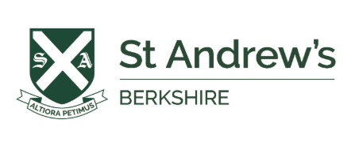
Century Assignments for Year 5 Summer Holidays
 | English | Maths* | Verbal
Week 1  6th July | -Identifying word classes  -Abstract and concrete nouns  -Statement, question, exclamation, command | -Diagnostic: Mixed operations  -Negative numbers 2  -Highest common factor | - Missing letter
Week 2  13th July | -Identifying the meaning of words  -Suffixes  -Bookwork comp | -Solving two step problems  -Prime numbers  -BIDMAS introduction | -Finding the missing word  -Following a pattern to make a word
Week 3  20th July | -Verbs  -Adverbs  -Subject and object | -Diagnostic: Fractions  -Cube numbers  -+/- Improper fractions and mixed numbers | -Following a pattern (word pairs)
Week 4  27th July | -Inferring from description  -Antonyms  -English Civil War comp | -Finding the whole  -Multiplying mixed numbers  - +/- Fractions  -Multiplying decimals | - Synonyms  - Antonyms
Week 5  3rd August | -Relative pronouns  -Subordinating and coordinating conjunctions  -Diagnostic: word classes | -Comparing decimals  - +/- Decimals  - Finding percentages  -Finding percentages of amounts 2 | -Homographs (different meanings)  - Connecting words (complete the sentence)
Week 6  10th August | -Metaphors  -Onomatopoeia  -Diagnostic 1 - Comprehension | -Diagnostic: Fractions, decimals, percentages  -Solving length problems with conversion  -Important sequences: square/cube/triangular | - Sentence order  - Connecting letters
Week 7  17th August | -Standard English  -Past progressive tense  -Subordinate clauses | -Diagnostic: Time  -Solving capacity problems + conversion  -Angles in quadrilaterals | - Word problems
Week 8  24th August | -Personification  -Finding answers and explaining them  -A Little Princess comp | -Angles on a straight line  -Reflection  -Line graphs  - Finding the mean | - Mixed up words  - Words within words
Week 9  31st August | - Determiners  -Year 5 SPAG Assessment  -Inferences in poetry | -Volume of cubes and cuboids  -Problem solving and reasoning assessment  -Practice assessment 1 | -Mixed up words in a sentence

*These nuggets are challenge nuggets. Some may wish to do these to stretch or in place of nuggets that are already secure.

